DAX Studio

This chapter will demonstrate some query skills on DAX language in the DAX studio tool. The quarries based on a logical business needs.

Attached related script.

Attached pictures of the data sets:

1) Adding column to usage main table from counties table

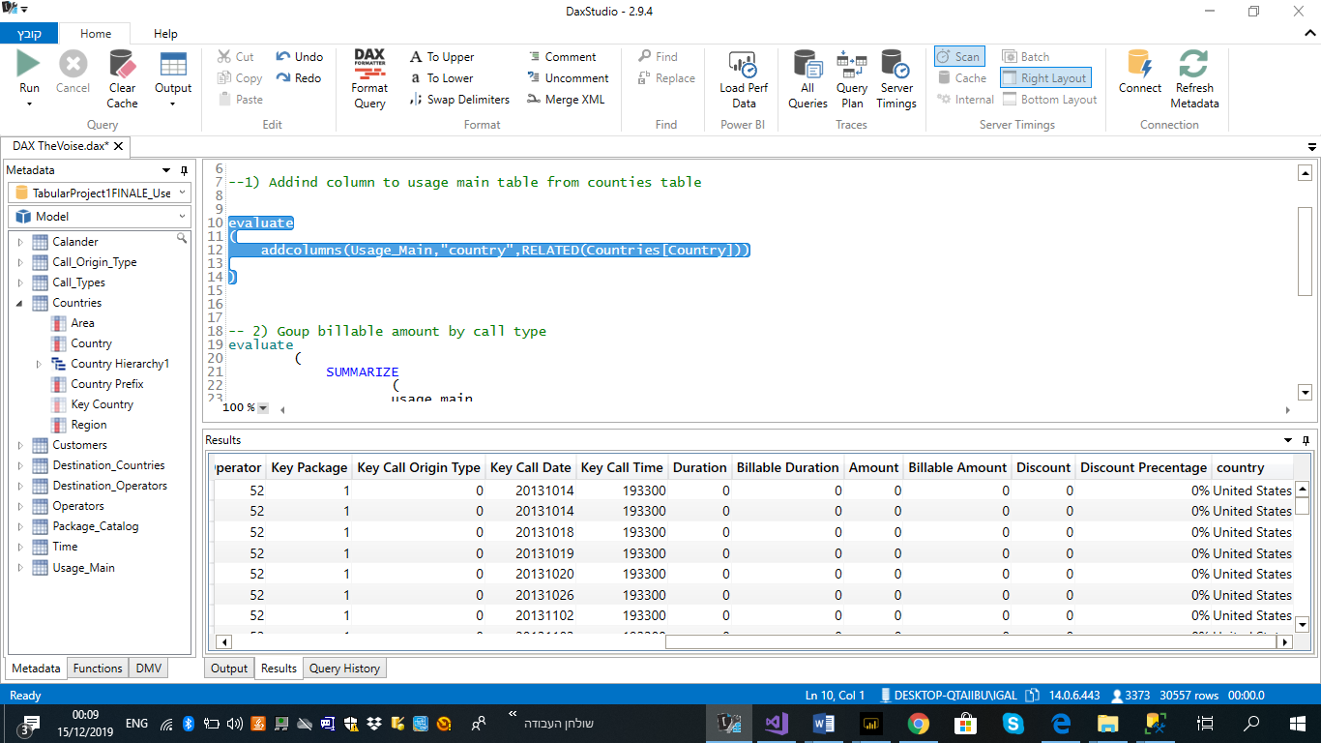

2) Group billable amount by call type

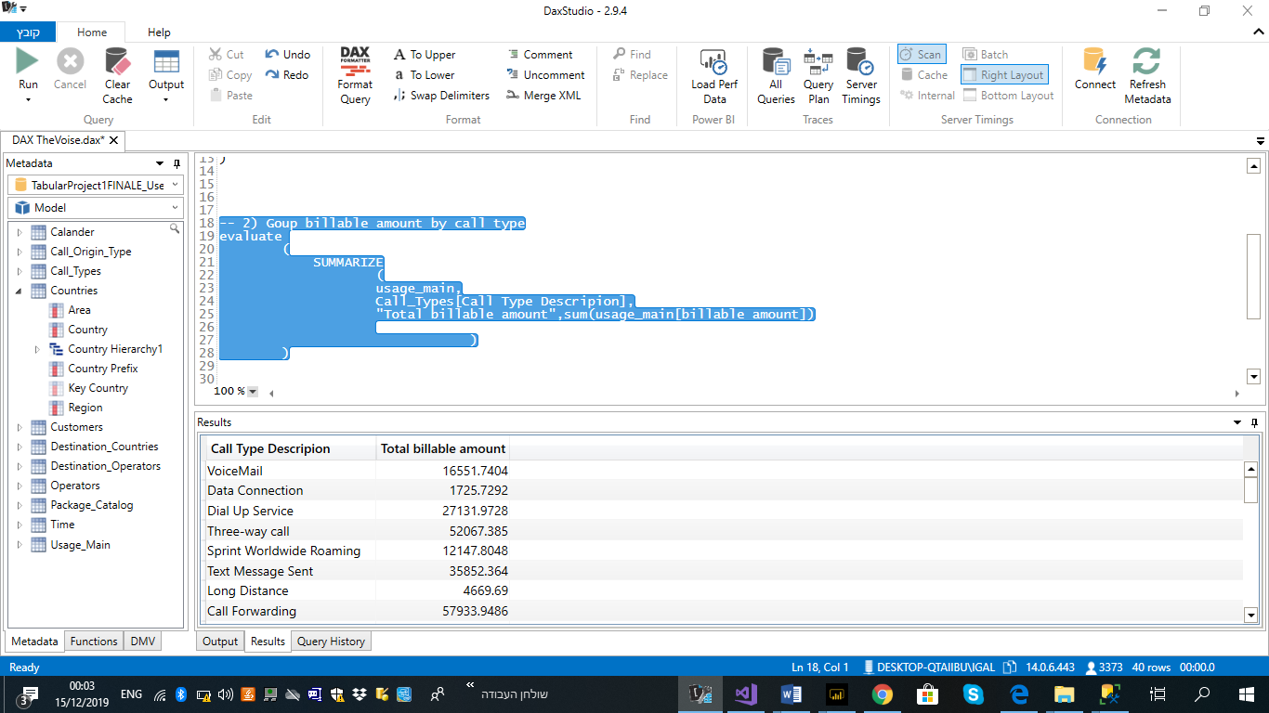

3) Shows only countries in region 'Americas'

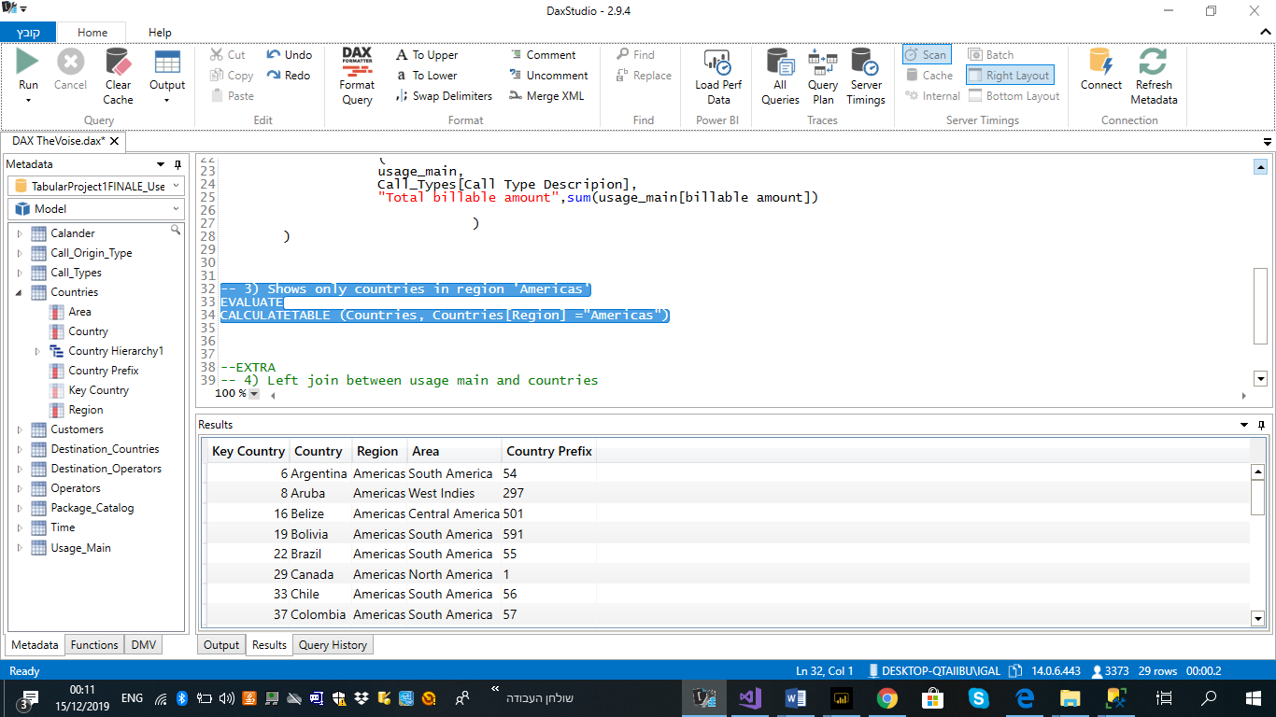

4) Left join between usage main and countries